Population Dynamics and Space Availability
(http://web.as.uky.edu/Biology/faculty/cooper/Population%20dynamics%20examples%20with%20fruit%20flies/TheAmericanBiologyTeacher-PopulationDynamicsWebpage.html )

Introduction
We have already examined how initial population size affects how quickly a population can grow and how limited food limits population size. If you need a review of this material, please look over the material presented earlier in the module. We are going to use what we learned earlier to examine how space availability can constrain populations. Much like food, space is necessary for an organism to function. If space is limited, individuals in a population have to compete for it. In this portion of the module, we will design and execute an experiment to examine how space availability influences the dynamics of a fruit fly population.

Hypothesis Forming
Since we are aiming to observe how limitations on space alter a population’s dynamics, we should form a hypothesis as to what the relationship may be. Of the following hypotheses, which makes the most sense building on what you know about the importance of space? Why?
- Populations with more space will grow to a smaller size and less quickly than similar populations with less space available.
- Populations with more space will grow to a smaller size and more quickly than similar populations with less space available.
- Populations with more space will grow to a larger size and less quickly than similar populations with less space available.
- Populations with more space will grow to a larger size and more quickly than similar populations with less space available.

Experimental Design
To test our hypothesis, we must design an experiment that varies our independent variable and allows us to quantify our dependent variable. Our independent variable (amount of space available) must vary across the experimental trials, and the dependent variables (rate of population growth and size of the population) can then be assessed. All other variables should be held constant across the trials. For the following variables explain how you would keep them constant across trials:
- Food Availability
- Water Availability
- Temperature
- Light Exposure

In this experiment, we are going to use a portion of data you have already collected. From the portion of the module concerning pupation rates, please gather both the raw data as well as the Joinpoint graph for the initial population of four adults. You will notice that the following procedure is very similar to the one from earlier in the module, with the exception that the vials are larger and you only use one initial population size.
Procedure
Establishing Populations in Large Vials:
- Prepare three vials (larger than those used in the earlier trials) with a food substance.
- Obtain cotton balls, or other material that allows gas exchange, that can be used to contain flies within the vials. In the sample experiment, a sponge material was used.
- Using a piece of masking tape, label each of the three large vials with the first three letters of the alphabet (A-C).
- Using CO₂, anesthetize a large vial of CS flies.
- Either with a microscope, magnifying glass, or naked eye, determine the sex of each fly and place them in piles accordingly. In order to sex each fly, you must be familiar with the characters that distinguish the two sexes. Please see the included sex-determining guide for more information.
- In each vial, place one male and three female fruit flies. While they are unconscious, it is important not to let them fall in the food. They may stick to it and eventually die. Instead, hold the vial on its side, and place each unconscious fly in the interior.
- Ensure the flies don’t escape by placing the cotton ball or sponge snuggly within the open end of the vial. Leave it lying on its side until the flies begin moving around.
- Once the flies have woken up, you can safely place the vial upright. Your setup should look be similar to the setup you had earlier when you examined pupation rates. The only difference is that the vials should be significantly larger.

Monitoring Pupa Formation in the Vials:
- Prepare a table in which to document the date and time of each recording and the number of pupa counted at that time for each vial.
- Check each of the vials daily for the first signs of pupa formation. It may take several days to a week before pupa begin to form. You will first notice the movement of larvae within the food medium. After a few days, the larvae will begin climbing on the sides of the vial walls. They will then become stationary and begin changing from a yellowish white to a much darker brown color. The color change marks the transition into the pupa stage.
- On each vial, use a fine point marker to circle each newly formed pupa. You may number these, and then document the number counted in your table. Marking each one ensures you will not recount the same pupa.
- After the first pupa forms, the vials should be monitored twice daily. Ideally, the two recordings would occur about twelve hours apart. At each instance, record the number of newly formed pupa since the last time they were counted. Continue to also use a marker to mark each pupa.

- Continue counting and marking the pupa twice daily until the amount of elapsed hours is roughly equivalent to the amount of hours in the earlier pupation trial. This should be about a week after the first pupa was documented. Please note that this may happen after some adults begin to eclose. This is fine and shouldn’t impact the data. The vials should look similar to those in the image below:
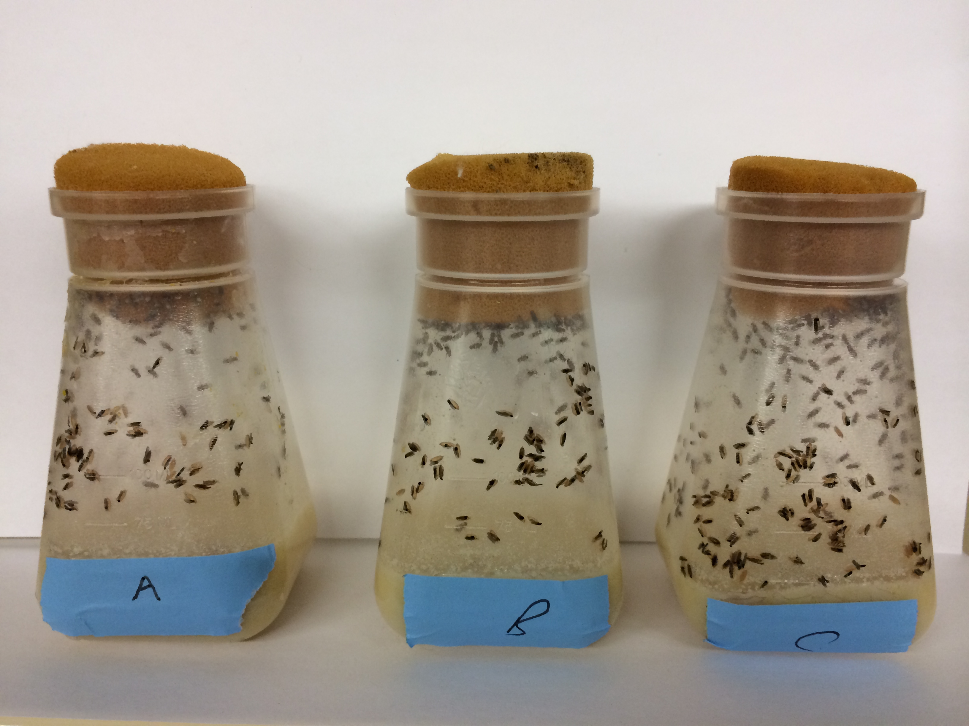

Data Analysis
The data analysis in this section is very similar to the analysis performed on pupation and eclosion data earlier in the module. As review, this section will give step-by-step instructions on how to analyze this data. It will require the use of two computer programs (Excel and Joinpoint, which can be downloaded for free). The following steps will be used for the pupation data in the larger vials.

Using Excel and Joinpoint to Analyze Data:
- Upon completion of data collection, you should have a table containing the number of new pupa (or adults) recorded at different times over the duration of the experiment. This data should be imported into Excel. Please visit the module website (which can be found on page 1) to download the template.
- On the website, please watch one of the videos demonstrating how to properly input and edit the data. There are versions for both Macs and PCs. Some steps are only described in the videos, so please pay attention. (Note: screenshots are taken on a Macintosh running Excel 2011. Some items and options may appear differently on your computer).
- The calculations portion of the spreadsheet contains all of the functions that need to be carried out. It will pull data from the “Insert Data” tab to be used in the calculations. From this analysis the only calculated information needed is the average total of pupa (or adults) at each time for the two treatment levels (two initial flies or four initial flies) and the total hours elapsed at each data point. This data will appear in the “Joinpoint Data” tab.
- To next portion of the analysis will occur in Joinpoint software. Go to the tab called “Joinpoint Data,” and go to File, then Save As…

- Under “Format” choose “Windows Formatted Text (.txt)” and choose a location you will remember.
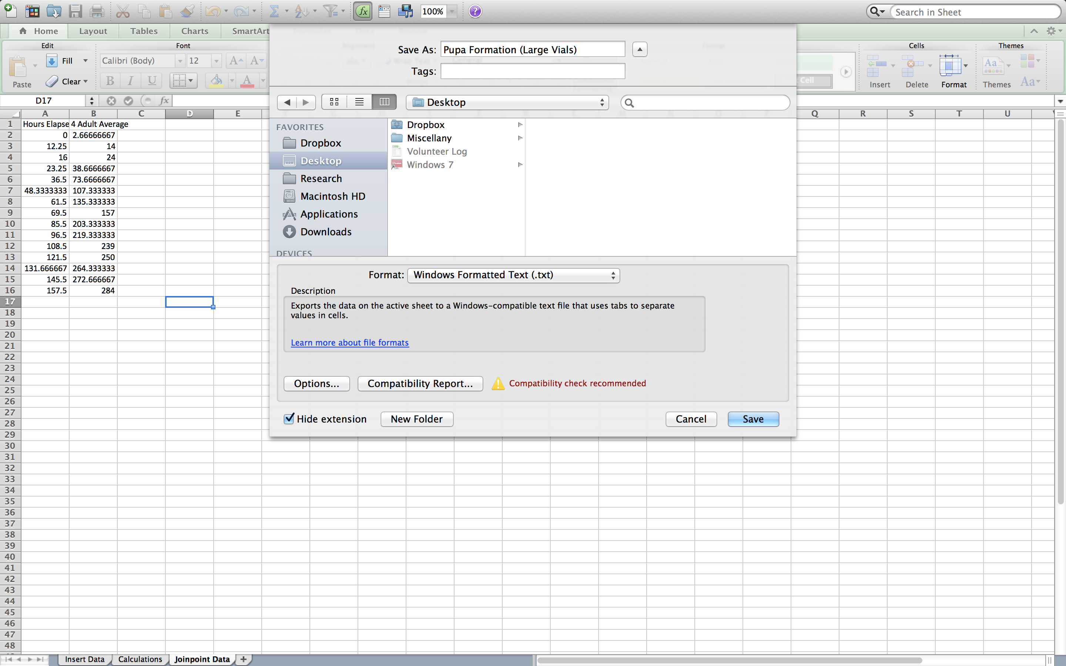
- You may be prompted with two popups. You will want to “Save Active Sheet” and “Continue” when prompted.
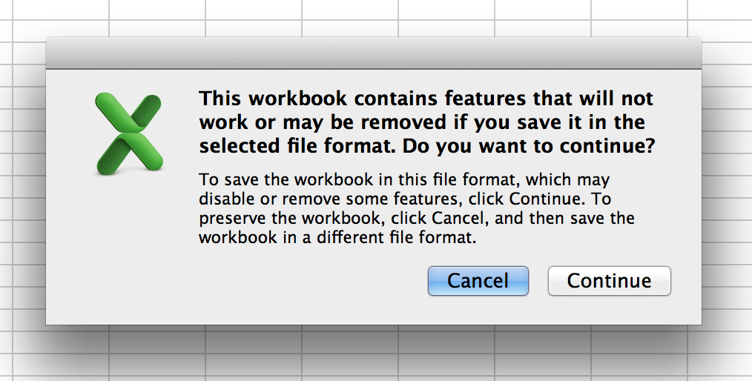
- Using the video from step 2 as a guide, please remove the extraneous information from the data file. Once it is properly prepared, properly save it for Joinpoint analysis.

- This saves the data in a format that Joinpoint can open. To continue analyzing the data, you will need to download and install Joinpoint from their website (https://surveillance.cancer.gov/joinpoint/download). You will have to fill out a brief form, and you’ll receive an email with download information.
- Once it is installed, open the program and navigate to “File,” then “New,” then “Blank Session.”
- A new window will open. In the “Input Data File” box, you will want to “Browse” and locate the .txt file you saved from Excel. Once you found it, click to open.
- Another window should open similar to the one below. In the “Dependent Variable Information” section, click “Provided” and “Count” under “Type.” Press “Ok.”
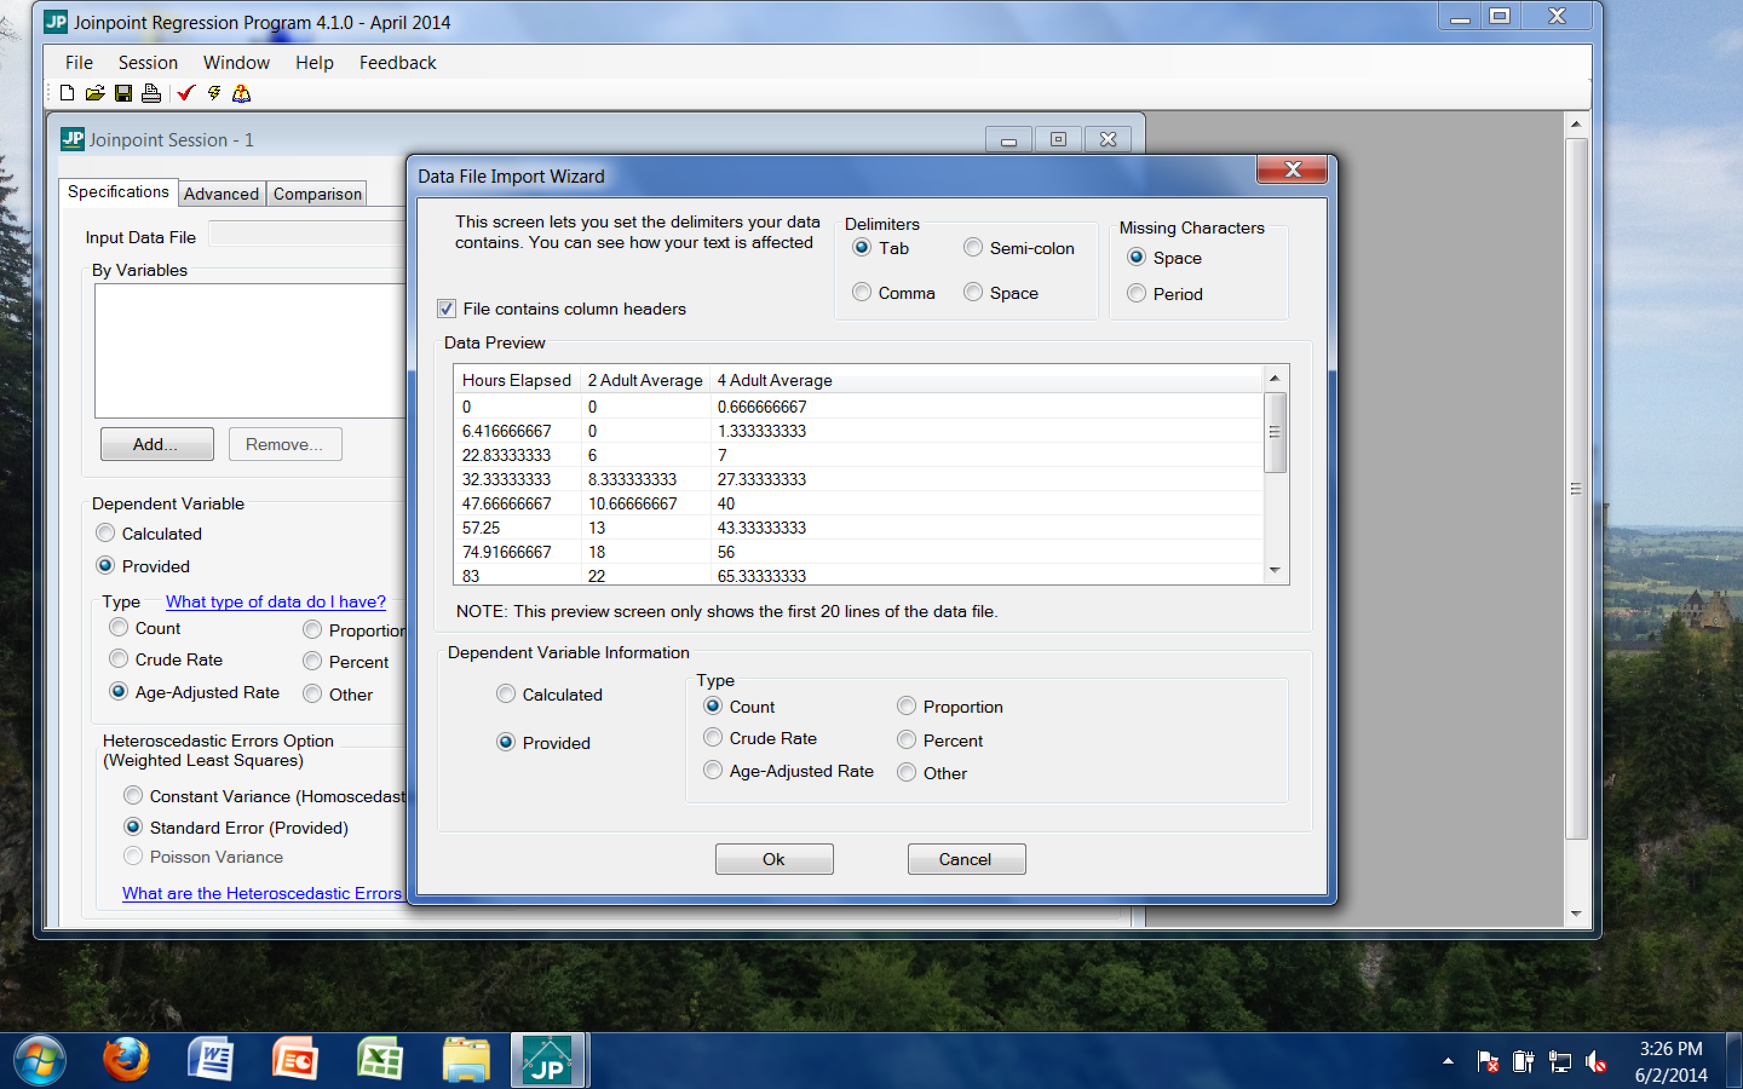
- When prompted to keep current variable definitions, click “No.”
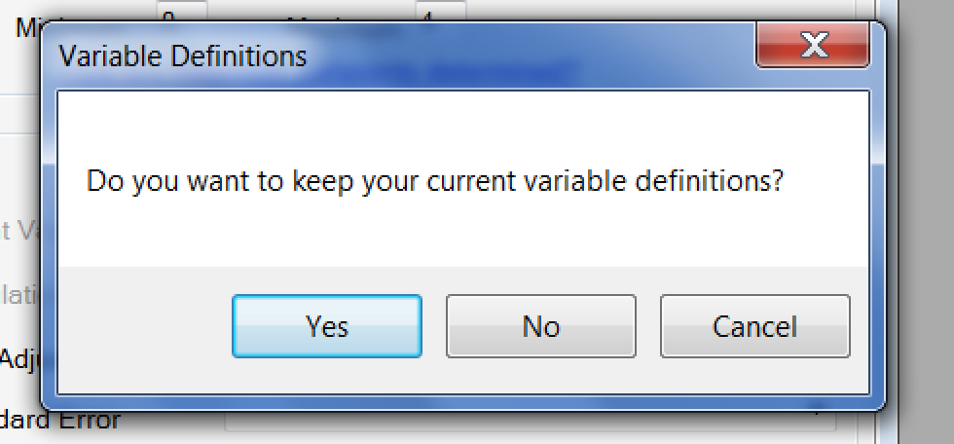

- Then adjust all values to reflect those in the following screenshot. Independent Variable should be “Hours Elapsed,” maximum number of Joinpoints should be “4,” count variable should be “4 Adult Average,” errors option should be “Constant Variance,” and log transformation should be “No.”
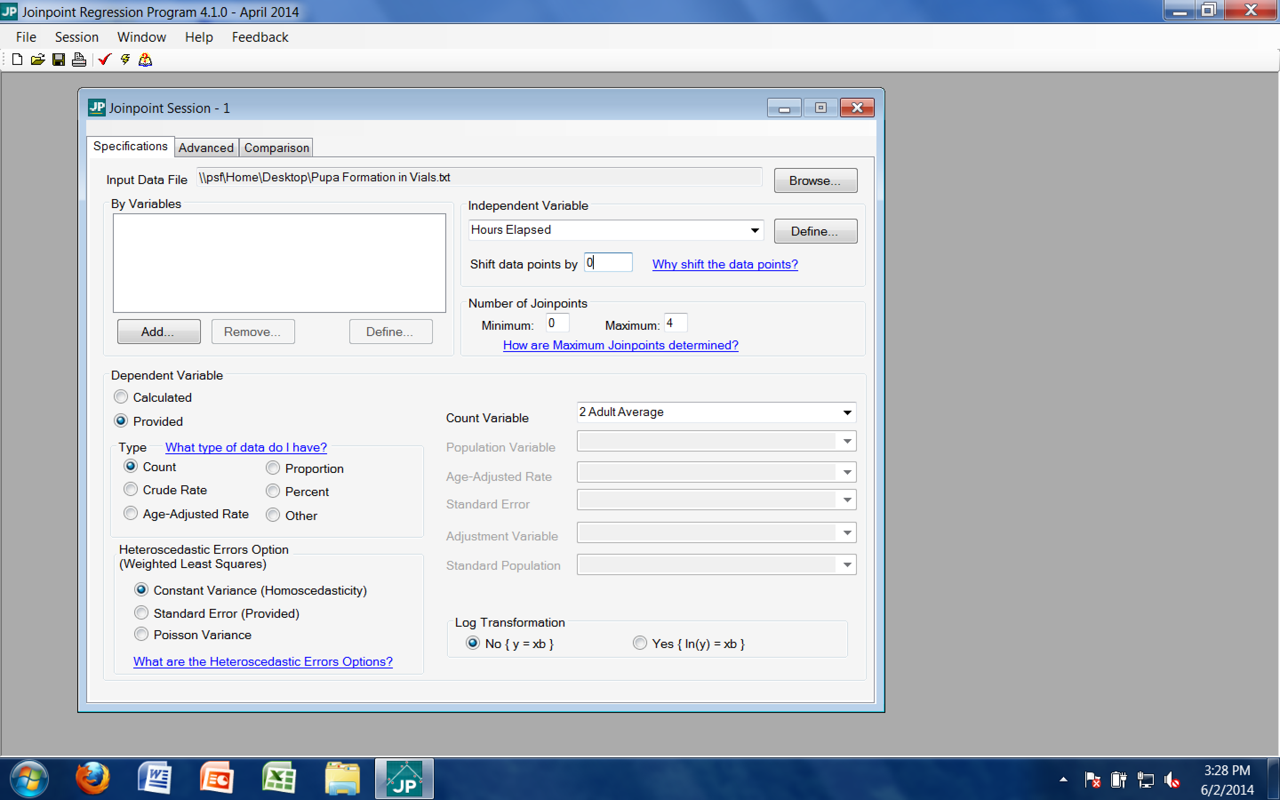
- After all of those settings have been adjusted, click on the little lightning bolt on the tool bar. It is between a checkmark and a book with a question mark. This will execute the analysis of the data.
- Once it is finished, a window will open with the output of the analysis. The Joinpoint software will analyze the data and complete piecewise linear regressions. This will result in a graph including the data points and lines of fit for the data. These lines, and particularly their slopes, will be useful in drawing conclusions.
- Before we examine the output, the graph must be properly labeled. Click on the “Display Options” button in the toolbar. It looks like a hand holding a piece of paper.
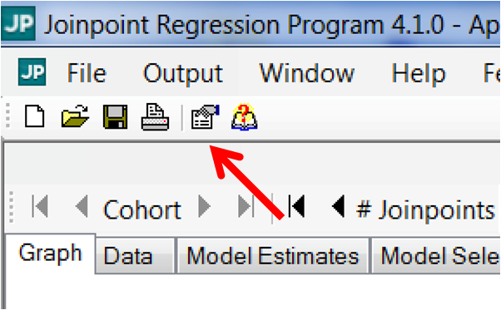

- From this menu, appropriate axis labels and title can be added to the graph. The x-axis should be labeled to reflect the independent variable (elapsed hours), and the y-axis should be labeled to reflect the dependent variable (number of pupa formed, in this case). The title of the graph should reflect the conditions of this particular trial. For this analysis, the text should be similar to that below:
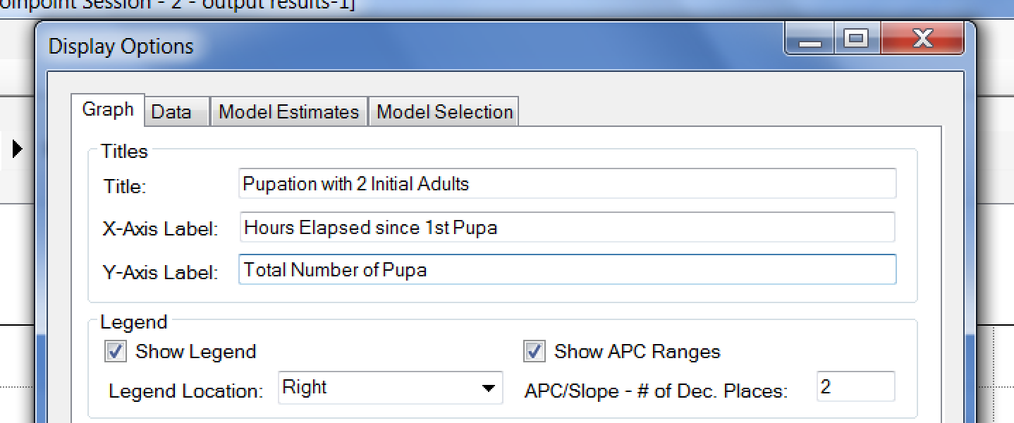

- Clicking “Apply” will add the labels to the graph. This should result in a graph that has all of the necessary elements to properly draw conclusions. For now, we will save the graph for later analysis. Go to the “Output” on the toolbar and click “Export.”
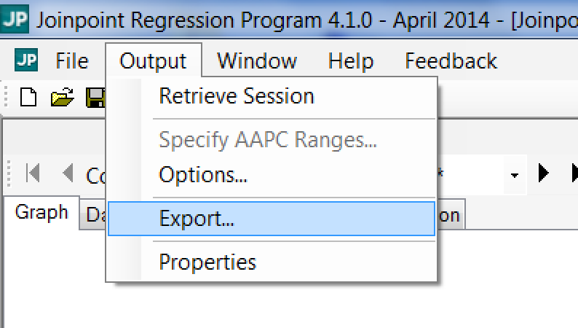

- In the Export menu, ensure the check box for “Displayed Graph” is checked and browse for a location to save it that you will remember. Name the file the same as the graph title. In this case, the file would be named “Pupation with 4 Initial Adults in Larger Vials.” The options should appear similar to that below:
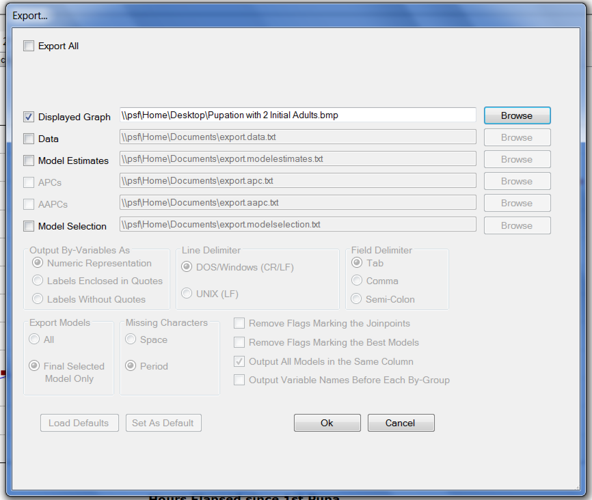
- Clicking “Ok” will export the graph to the designated location in picture format. In this case, the graph was saved as a file on the desktop. Please save this graph for further analysis.

Reading Joinpoint Graphs:
- At this point, you should have successfully exported your graph from Joinpoint for the data collected from the larger vials. Please retrieve the graph made earlier of pupation data with four initial adults in the smaller vials.

- Let’s start by comparing the graphs. Between the two graphs, discuss differences in overall shape, steepness of the lines of fit, and overall number of pupa. Did one graph reach a higher number of pupa in the time period? If so, which one?

- On the right side of each graph, there should be a legend that displays the slopes of the regression lines for that graph. Look at the example taken from a trial with 4 initial adults:
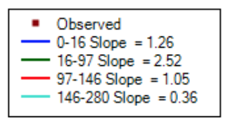
In this example, there are four piecewise regressions. The first one ranges from the beginning of the trial to when 16 hours had elapsed. The second ranges from the 16-hour mark to when 97 hours had elapsed, and so on. Next to the domain of each regression, the slope for that portion is identified. Please make note of the domain and slope of the regressions for each of your two graphs.

- Now examine how pupation rate differs between the two trials. Compare them on a piece-by-piece basis. Looking at the beginning, middle, and end of each trial, how do they compare? Is one of them consistently faster than the other? If so, which one?

Drawing Conclusions
At this point, you have formed a hypothesis related to how space available may impact a population’s dynamics, collected data from an experiment to test that hypothesis, and analyzed the data to make it easier to draw conclusions. Now it is time to build on everything you’ve done and draw conclusions from the analysis. Review your responses to the questions in the “Reading Joinpoint Graphs” section.

Conclusion questions:
- Is there a relationship between amount of space available and how large the population grows? If so, what is it?
- Is there a relationship between amount of space available and how quickly the population grows? If so, what is it?
- Do the observed relationships support or refute the hypothesis from earlier? Why or why not?
- Do the observed results align with what you already know about competition for space?

Challenge questions:
- Earlier in the module, we examined how the initial population size impacted how quickly a population grew. If this experiment were repeated with two initial adults (one male and one female) instead of four in the larger vials, what would change? Would the final population size be larger, smaller, or the same at completion? Would the population grow faster, slower, or at the same rate? Explain your conclusions.
- The larger vials had both more space on the interior (increased volume) and more space on the walls (increased surface area). Which do you think plays a larger role in influencing population dynamics? Consider how the flies occupy space at different stages in their life cycles. Design an experiment to test this hypothesis.
- In this experiment, should the larger vial have a similar sized opening to the small vial? Consider how a different sized opening could alter how gas is exchanged between the interior and exterior of the vial. What impact would having a larger opening have on the population dynamics? Could this factor be at play in the experiment performed?
- Drawing on everything learned in this module, which factor (initial population size, food available, or space available) is most important in determining final population size? Which are more important in determining how quickly a population grows?

